Things to change:
Home page:
“Ready to elevate your business operations”
- The thing about having 150+ projects and 50+ clients is not true yet. This can be instead changed to either that the aspiration is to one day complete 150+ projects or it must be removed entirely.

About page:
“Building South Africa’s industrial future”
- 50+ clients (must be removed)
- 150+ (must be removed or changed into an aspiration)
- 200 skilled professionals must be removed
“Our journey”
- 2022. The ISO certification part should be changed to ISO QMS (Quality Management System). This is important because if companies will require us to produce the certification, which we yet do not have
This can be changed to:

2022:
ISO Quality Management System (QMS)
Caption under: Our QMS is aligned to ISO (ISO 9001 – 2015)

- 2024-25
Instead of saying “Reached 150+ completed projects milestone and established partnerships with leading industrial companies.”, change it and say that the aspiration would be to reach 150+ completed projects.

“Meet our Leadership”
- I understand that the names there are placeholders. The people fill in these actual roles are currently being updated so the placeholders aren’t going to be an issue for now. The correct names will be given in time.

Services Page:
Perfect

Projects Page:
Our assumption is that most of these projects also act as placeholders (which we are expecting to be removed by the time the website has been completed)

Compliance Page:
“CoC licenced”
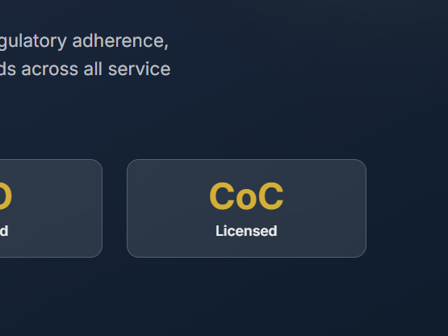
We are not CoC licensed as of yet, however collaborative efforts with other electrical companies that are CoC licensed have been taken.
“Certifications and compliance”
We do not have a Health and safety certification but we are compliant.

Contact page:
Assumptions are that some of those locations have been used as placeholders, only the first location is true.

Additional:
One of the phone numbers should change from +27 72 585 8196 to +27 72 584 8196

